[DEPARTMENT LETTERHEAD]

FOR IMMEDIATE RELEASE
[DATE]
[AGENCY CONTACT INFORMATION]

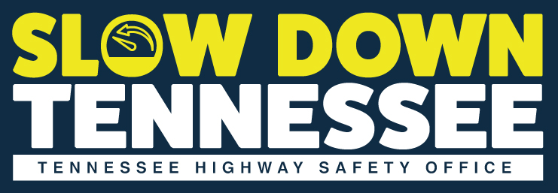
[AGENCY NAME] PROMOTES “SLOW DOWN TENNESSEE” TO REDUCE SPEEDING-RELATED CRASHES
[City, State] – [Agency Name] is partnering with the Tennessee Highway Safety Office (THSO) for “Slow Down Tennessee.” During April 14 – 28, [Agency Name] will increase education, awareness, and enforcement efforts to help reduce speeding-related crashes, injuries, and fatalities statewide.
[Insert local speeding-related crash data]

[Quote from Agency Representative]

[Insert specific information on what your agency will be doing to reduce speeding]

The State of Tennessee requires motorists to always exercise due care and maintain a safe speed while driving. Speed limits may vary depending on the county and road conditions; therefore, drivers must always pay attention and adhere to posted speed limits to ensure the safety of all roadway users.
For more information about speeding, visit www.tntrafficsafety.org/speeding.
# # #

