[Department Letterhead]
FOR IMMEDIATE RELEASE
[DATE]
[CONTACT INFORMATION]
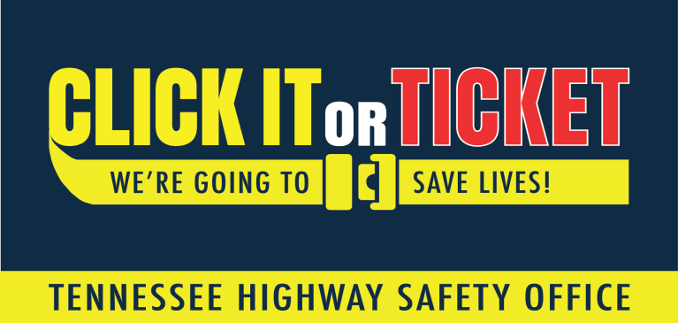
[AGENCY NAME] INCREASES SEAT BELT ENFORCEMENT DURING NATIONAL “CLICK IT OR TICKET” MOBILIZATION
[City, State] – As summer kicks off and families hit the road for vacation, [Agency Name] is partnering with the Tennessee Highway Safety Office (THSO) to remind motorists to “Click It or Ticket.” From May 23 through June 5, participating agencies across the state will increase seat belt enforcement as part of the National Highway Traffic Safety Administration’s (NHTSA) nationwide mobilization.
“Buckling up is such a simple task that can keep you and your family safe in the car,” said [Agency spokesperson]. “But it’s more than that. Buckling up is the law. Our law enforcement officers see the consequences of not buckling up. We see the loss of life. Often, it could have been prevented with the simple click of a seat belt. This should be automatic.”
[Insert local crash data]
According to NHTSA, in 2020, there were 10,893 unbuckled passenger vehicle occupants killed in crashes in the United States. In that same year, 58 percent of passenger vehicle occupants killed at night (6 p.m. – 5:59 a.m.) were not wearing their seat belts. That’s why one focus of the “Click It or Ticket” campaign is nighttime enforcement. Participating law enforcement agencies will be taking a no-excuses approach to seat belt law enforcement, writing citations day and night. In [Insert jurisdiction], the maximum penalty for a seat belt violation is [Insert details].
For more information about seat belt safety, visit www.tntrafficsafety.org/seat-belts.

